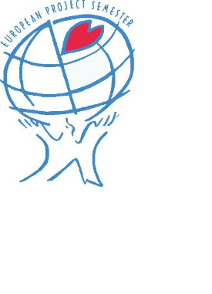
The European Project Semester (EPS) is a one-semester programme offered by 19 universities from 12 European countries to students who have completed at least two years of higher education studies. The concept EPS was created in Denmark by Prof. Arvid Andersen in 1995 with engineering students in mind, but other students who can participate in an engineering project are also welcome. It is crafted to address the design requirements of the degree and prepare engineering students with all the necessary skills to face the challenges of today’s world economy. EPS is a mixture of “Project Related Courses” and project-organized/​problem-based learning. Students work in international and usually multidisciplinary teams of 3 to 6 students on their projects, and most of the projects are interdisciplinary. Some projects are done in cooperation with businesses and industries, other projects with research laboratories. Students learn to learn, to take responsibility for their learning and their project work and develop inter-cultural competencies, communication skills and interpersonal skills. For + info: European Project Semester Providers
The European Project Semester at ISEP (EPS@ISEP) is a 30 ECTU programme in English offered by ISEP to international 3rd and 4th year (or higher level) engineering, product design and business students. The programme comprises the following modules:
- Project (20 ECTU)
- Team Building & Project Management (2 ECTU)
  - Marketing & Communication (2 ECTU)
  - Ethics & Deontology (2 ECTU)
  - Energy & Sustainable Development (2 ECTU)
  - Portuguese (2 ECTU)
It is a project-based learning offer with emphasis on teamwork, involving groups of students from different majors and cultures, to solve real-world multidisciplinary problems.
EPS@ISEP, which was launched in 2010/2011, is currently on its 13th edition!

